**CHEYENNE’S FOOD IDEAS <3   
  
Contents:**

**Page 2 – Garlic 2 minute noodles   
Page 3 – Spicy 2 minute noddles   
Page 4 – feta & cherry tomato pasta   
Page 5 – Penne pasta w/ bacon & parmesan   
Page 6 – Butter & garlic pasta   
Page 7 – Chicken ceasar salad  
Page 8 – Balsamic vinegar salad   
Page 9 – Pita pockets  
Page 10 – Cheese & spaghetti toastie  
Page 11 – Jacket potato**

**2.  
GARLIC 2 MINUTE NOODLES - WOOLWORTHS:**Ingredients:Nissin Ramen Kyushu Black 5 Pack   
Fried egg  
Bacon  
Spring onion  
Sliced Jalapenos White and black sesame seeds   
Siracha   
  
  
1. Cook bacon bits in saucepan until crispy   
2. Wipe oil from saucepan   
3. Add 350ml of water per packet of noodles to saucepan, wait until boil & add noodles  
4. Add ramen seasoning whilst it is cooking  
5. Reduce heat to medium   
6. Crack egg in centre of noodles  
7. Add egg, sliced bacon, spring onion and sliced jalapenos to noodles  
8. Season with sesame seeds

9. Add small amount of siracha if desired

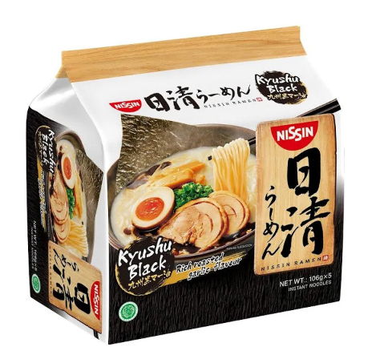

**3.  
SPICY 2 MINUTE NOODLES UPGRADE (WOOLWORTHS):**Ingredients:Ottogi Jin Ramen Mild Instant Noodles  
1 Egg

American style cheese  
Spring onion  
  
1. Add 350ml of water per packet of noodles to saucepan, wait until boil & add noodles  
2. Add ½ seasoning for ramen whilst it is cooking  
3. Reduce heat to medium   
4. Crack egg in centre of noodles

5. Cut slices of cheese into 2 triangles and add on either side of egg   
6. Add green onions on top  
7. Put lid on top of saucepan until egg is cooked   
  
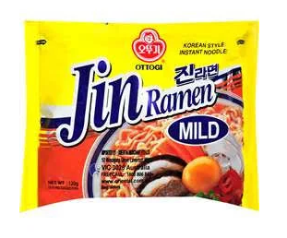

**4.**

**FETA & CHERRY TOMATO PASTA (COLES/WOOLWORTHS):**Ingredients:Farfelle (bow) pasta - 1 ½ cups  
Cherry tomatoes – 2 cups   
Feta cheese – 1 block  
Minced garlic – 1 1/2 tbsp   
Basil leaves – ¼ cup  
Olive oil  
Salt & pepper

1. Add cherry tomatoes to baking dish   
2. Cover with ¼ cup olive oil

3. Add salt & pepper

4. Add feta cheese into middle of baking dish  
5. Add 1 tbsp olive oil on top & more pepper  
6. Bake 400°F / 200°C for 35 minutes  
7. Start to cook pasta   
8. Add garlic & basil leaves to finished baking dish immediately   
9. Mix well & add pasta

**5.  
PENNE W/ BACON, EGG & PARMASAN (COLES/WOOLWORTHS):**Ingredients:400g penne (tube) pasta  
3 slices of pancetta   
¾ cup grated parmesan

½ cup chopped parsley

1 tbsp olive oil  
4 eggs, lightly whisked   
  
1. Cook pasta until done nearly done (about five minutes from being completed)  
2. Heat frying pan over medium-low heat. Cook, turning, the pancetta for 5 minutes or until golden and crisp. Remove pancetta and place on kitchen towel to drain fat & then chop up   
3. Drain & add the pasta to the pancetta fat in the pan. Stir over low heat for 1 minute or until coated. Remove from heat. Cool for 1 minute. Stir in the pancetta, parmesan, parsley and oil until combined. Quickly stir in the egg until the pasta is coated. Season with pepper.

**6.  
GARLIC BUTTER PASTA (COLES/WOOLWORTHS):**Ingredients:2 cups small pasta shells  
1 ½ tbsp garlic

½ cup butter

¼ cup grated parmesan   
2 tbsp fresh parsley   
Salt

Pepper

1.Cook pasta in saucepan until done  
2. Drain water – return to stove   
3. Mix in ingredients

**7.  
CHICKEN CEASER SALAD (COLES/WOOLWORTHS):**Ingredients:Chicken schnitzel  
Boiled egg   
Bacon bits

Croutons

Baby cos lettuce  
Shaved parmesan   
Ceasar dressing

1. Cook chicken in oven  
2. When nearly completed, heat up frying pan – add oil & cook bacon bits / hardboiled egg  
3. Remove bacon bits from pan, laying on paper towel to drain fat

4. With remaining oil & fat from bacon add croutons to saucepan to heat

5. Chop lettuce  
6. Add ingredients to bowl

**8.  
BALSAMIC VINEGAR SALAD (COLES/WOOLWORTHS):**Ingredients:¼ cup balsamic vinegar   
¼ cup olive oil  
1 tsp Dijon mustard  
1 tbsp honey  
Salt & pepper  
  
Mixed red leaf salad  
Red onion

Cucumber  
Cherry tomatoes  
Feta (crumbled)

Walnuts  
Sunflower seeds  
  
1. Combine vinegar, mustard, honey, salt & pepper into an empty jar & mix   
2. Cut up leafy greens mix  
3. Cut up onions, cherry tomatoes & slice cucumber long ways & in ¼

4. Crush walnuts – mix with sunflower seeds   
5. Add crumbled feta

**8.  
PITA POCKET (WOOLWORTHS):**Ingredients:Pita pockets  
American cheese  
Coleslaw

Shredded chicken

**9.  
SPAGHETTI & CHEESE TOASTIE (WOOLWORTHS/COLES):**Ingredients:Spaghetti  
Cheese   
Bread

**10.  
JACKET POTATO (WOOLWORTHS/COLES):**Ingredients:Potato  
Bacon bits

Cheese

Coleslaw